CHEF

Configuration Management Tool
CHEF Ruby or Erlang do language se mil kar bna h.

Chef is an automation tool. It is a Configuration Management (CM) tool that lets you automate processes and tasks across numerous servers and other devices of an organization in simple steps. Such a framework is highly beneficial to a company. (OPERATION TEAMS PART)

TWO TYPES OF CONFIGURATION MANAGEMENT TOOLS.
- PUSH BASED – Push config serve pushes config to the nodes. (Ansible, Salt Stack)
- PULL BASED – Pull config. nodes check with the server periodically and fetches the config. From it. (Chef, Pupet)

IAC (INFRASTRUCTURE AS CODE)

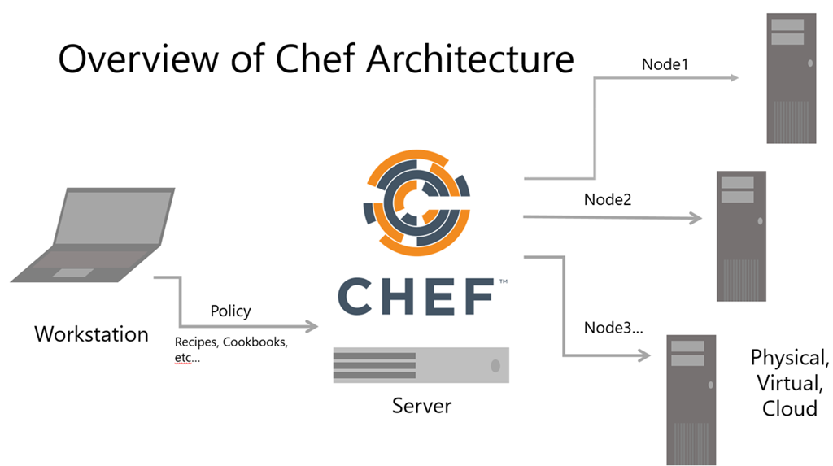
knife
knife
knife
knife

Workstation
- Workstation are personal computers or virtual servers where all config. Code is created, tested or changed.
- Devops engineer actually sits here and write codes this code is called recipe. A collection of recipes are known as cookbook.
- Workstation communicate with the chef server using knife.
- Knife is a command line took that uploads the cookbook to the server.
Chef-Server
- the chef-server is a middle man between workstation and the nodes.
- All cookbooks are stored here.
- Server may be hosted locally or remote.
Node
- Nodes are the systems that require the config.
- Ohai fetches the current state of the node its located in.
- Node communicate with the chef-server using the chef-client.
- Each node can have a different config. Required.
- Chef-client is installed on every node.
Chef workstation – where you write code.
Chef server – where you upload code.
Chef node - where you apply code.
Knife – tool to establish communication among workstation, server and node knife is a command line tool that runs on workstation.
Chef client – tool runs on every chef node to pull code from chef server.
Chef client will
- gather current system config.
- Download the desired system config. From the chef server.
- Configure the node such that it adhere to the policy.
Ohai – maintain current state information of chef code.
Idempotency – tracking the state of system resources to ensure that the changes should not reapply repeatedly.
Chef supermarket – where you get custom code.

Recipe = Infrastructure code. Recipe cookbook me hoti h. recipe me code likha hota h.
Recipe ka code Ruby me likha hota h.
Cookbook = collection of recipe. Cookbook workstation pe hoti h lekin save chef server pe hoti h.
Cookbook stores on server.
Knife – knife code ko workstation se chef server pe push krne ke lie use krte h or chef server se node pe push krne ke lie krte h.
Bootstrap – Server jab node se connect hota h to us process ko bootstrap khte h.
Chef Supermarket – yhan aapko sabhi tarike ki recipe or cookbook mil jayegi.
Chef workstation or node dono jagha install hoga.
Node pe Ohai or Chef-client do chije hoti h.
Ohai node ka database hota h.
Idempotency ohai new file or new code ko hi pickup krega old data ko nhi jo uske pas already rakha hua h. mtlb hum bar-bar kisi code ko repeat nhi krte.

